**Worksheet – 2.3**

**Student Name:** Vivek Kumar  **UID:** 21BCS8129

**Branch:** BE-CSE (LEET) **Section/Group:** 809/A

**Semester:** 4th **Date of Performance:** 03/04/2022

**Subject Name:** Programming in Python Lab  **Subject Code:** 20CSP-259

**1. Aim/Overview of the practical:**

1. Write a Python program to combine two dictionary adding values for common keys. d1 = {'a': 100, 'b': 200, 'c':300}, d2 = {'a': 300, 'b': 200, 'd':400}
2. Write a Python program to find the highest 3 values of corresponding keys in a dictionary.

**2. Task to be done/ Which logistics used:**

1. Write a Python program to combine two dictionary adding values for common keys. d1 = {'a': 100, 'b': 200, 'c':300}, d2 = {'a': 300, 'b': 200, 'd':400}
2. Write a Python program to find the highest 3 values of corresponding keys in a dictionary.

**3. Steps for experiment/practical/Code:**

1. Write a Python program to combine two dictionary adding values for common keys.

**Sourse Code:**

d1 = {'a': 100, 'b': 200, 'c': 300}

d2 = {'a': 300, 'b': 200, 'd': 400}

for i in d2 :

if i in d1 :

d1[i] = d1[i] + d2[i]

else :

d1[i] = d2[i]

print(d1)

1. Write a Python program to find the highest 3 values of corresponding keys in a dictionary.

**Sourse Code:**

***#Method 1***

from collections import Counter

my_dict = {'a': 333, 'b': 4, 'c': 6, 'd': 5, 'e': 21, 'f':99, 'g':40}

k = Counter(my_dict)

high = k.most_common(3)

print("Dictionary with 3 highest values:")

print("Keys: Values")

for i in high:

print(i[0],":",i[1])

***# Method 2***

my_dict = {'a': 333, 'b': 4, 'c': 6, 'd': 5, 'e': 21, 'f':99, 'g':40}

my_keys = sorted(my_dict, key=my_dict.get, reverse=True)[:3]

print("Dictionary with 3 highest values:")

print("Keys: Values")

for i in my_keys:

print(i,':',my_dict[i])

**4. Result/Output/Writing Summary:**

1. Write a Python program to combine two dictionary adding values for common keys.

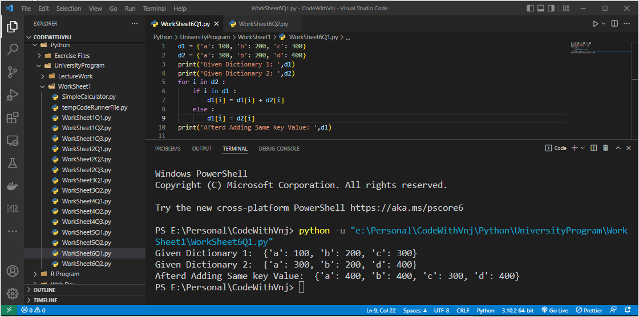

1. Write a Python program to find the highest 3 values of corresponding keys in a dictionary**.**

**Method 1:**

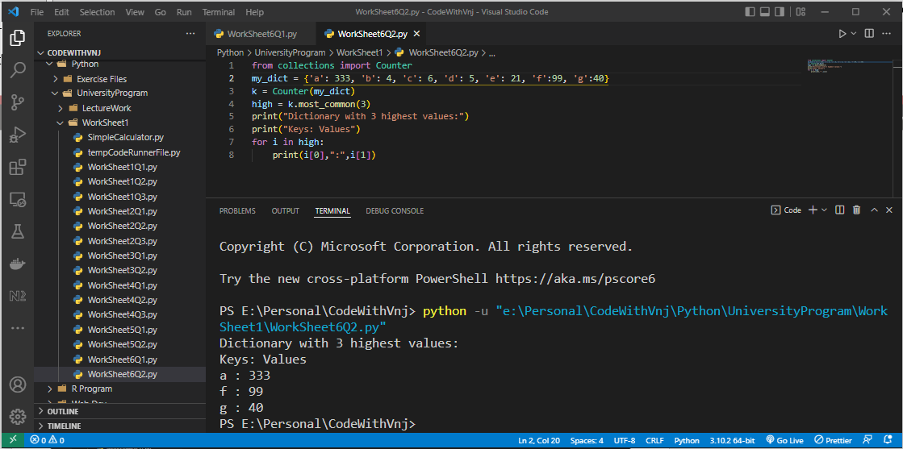

**Method 2:**

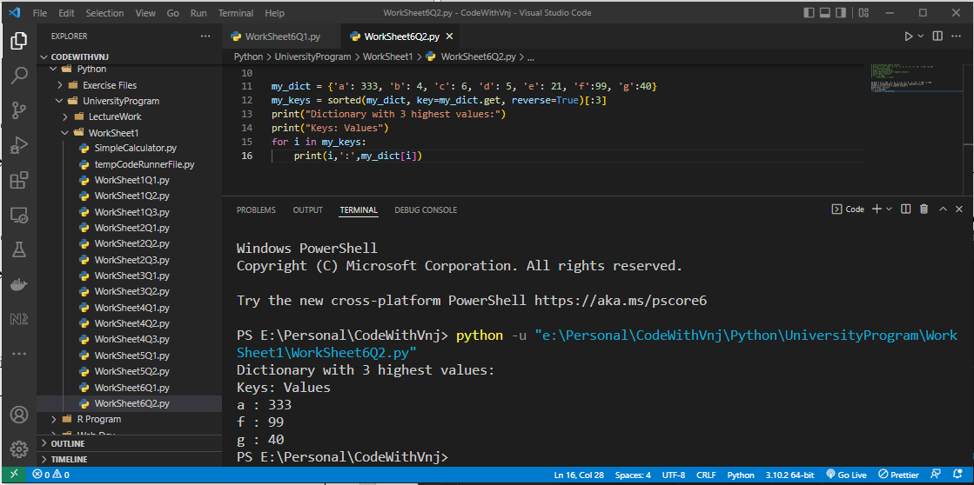

**Learning outcomes (What I have learnt):**

**1.** I have learnt, how to take List as well as Tuple Input from User.

**2.** Learnt to find the sorted tuple with their last element.

**3.** Learnt to List Manipulation.

**Evaluation Grid (To be created as per the SOP and Assessment guidelines by the faculty):**

|  |  |  |  |
| --- | --- | --- | --- |
| Sr. No. | Parameters | Marks Obtained | Maximum Marks |
| 1. |  |  |  |
| 2. |  |  |  |
| 3. |  |  |  |
| 4 |  |  |  |